**PRACTICAL NO 08**

**Designing the mobile app to implement the state management**

import 'package:flutter/material.dart';

var num1 = 24, num2 = 20, res = 0;

void main() {

  runApp(const Demo());

}

class Demo extends StatefulWidget {

  const Demo({super.key});

  @override

  State<Demo> createState() => _DemoState();

}

class _DemoState extends State<Demo> {

  var num1 = 20, num2 = 10, res = 0, res1 = 0, res2 = 1;

  double res3 = 1.0;

  void addNumbers() {

    setState(() {

      res = num1 + num2;

    });

    print("Addition Result: $res");

  }

  void subNumbers() {

    setState(() {

      res1 = num1 - num2;

    });

    print("Subtraction Result: $res1");

  }

  void multiNumbers() {

    setState(() {

      res2 = num1 * num2;

    });

    print("Multiplication Result: $res2");

  }

  void divNumbers() {

    setState(() {

      res3 = num1 / num2;

    });

    print("Division Result: $res3");

  }

  @override

  Widget build(BuildContext context) {

    return MaterialApp(

      theme:ThemeData(appBarTheme: AppBarTheme(color: Color.fromARGB(222, 15, 221, 232))),

      title: "Calc",

      home: Scaffold(

        appBar: AppBar(

          title: const Text("State Management"),

        ),

        body: Padding(

          padding: const EdgeInsets.all(30),

          child: Column(

            children: [

              Row(

                children: const [

                  Text(

                    "Calculator:",

                    style: TextStyle(fontSize: 25,backgroundColor: Color.fromARGB(222, 42, 194, 192)),

                  )

                ],

              ),

              Row(

                children: [

                  ElevatedButton(

                    onPressed: () {

                      addNumbers();

                    },

                    child: const Text("Add"),

                  ),

                ],

              ),

              Row(

                children: [

                  Text("Addition Result: $res", style: const TextStyle(fontSize: 20)),

                ],

              ),

              Row(

                children: [

                  ElevatedButton(

                    onPressed: () {

                      subNumbers();

                    },

                    child: const Text("Subtract"),

                  ),

                ],

              ),

              Row(

                children: [

                  Text("Subtraction Result: $res1", style: const TextStyle(fontSize: 20)),

                ],

              ),

              Row(

                children: [

                  ElevatedButton(

                    onPressed: () {

                      multiNumbers();

                    },

                    child: const Text("Multiply"),

                  ),

                ],

              ),

              Row(

                children: [

                  Text("Multiplication Result: $res2", style: const TextStyle(fontSize: 20)),

                ],

              ),

              Row(

                children: [

                  ElevatedButton(

                    onPressed: () {

                      divNumbers();

                    },

                    child: const Text("Divide"),

                  ),

                ],

              ),

              Row(

                children: [

                  Text("Division Result: $res3", style: const TextStyle(fontSize: 20)),

                ],

              ),

            ],

          ),

        ),

      ),

    );

  }

}

**OUTPUT:**

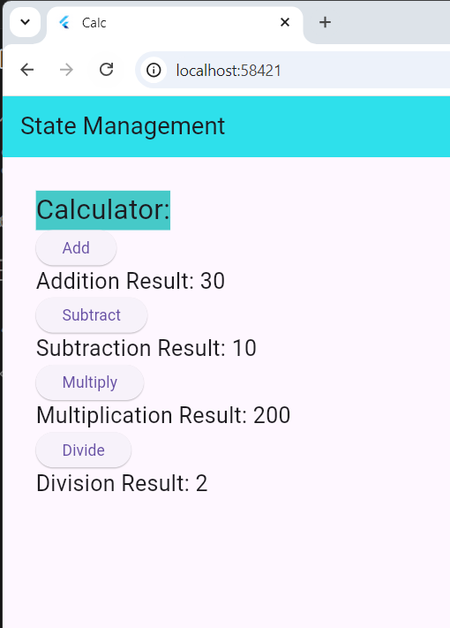

**PRACTICAL NO 07**

**a)Designing the mobile app to implement the animation.**

import 'package:flutter/material.dart';

void main() {

runApp(MyApp());

}

class MyApp extends StatelessWidget {

@override

Widget build(BuildContext context) {

return MaterialApp(

title: 'Flutter Animation Demo',

home: AnimationExample(),

);

}

}

class AnimationExample extends StatefulWidget {

@override

_AnimationExampleState createState() => _AnimationExampleState();

}

class _AnimationExampleState extends State<AnimationExample> {

double _opacity = 0.0;

@override

void initState() {

super.initState();

// Delay the animation for 1 second

Future.delayed(Duration(seconds: 1), () {

setState(() {

_opacity = 1.0; // Change opacity to 1

});

});

}

@override

Widget build(BuildContext context) {

return Scaffold(

appBar: AppBar(title: Text('Fade In Animation')),

body: Center(

child: AnimatedOpacity(

opacity: _opacity,

duration: Duration(seconds: 2),

child: Container(

width: 200,

height: 100,

color: Colors.blue,

alignment: Alignment.center,

child: Text(

'Hello, Flutter!',

style: TextStyle(color: Colors.white, fontSize: 20),

),

),

),

),

);

}

}

class ScaleAnimationExample extends StatefulWidget {

@override

_ScaleAnimationExampleState createState() => _ScaleAnimationExampleState();

}

@override

Widget build(BuildContext context) {

return Scaffold(

appBar: AppBar(title: Text('Fade In Animation')),

body: Center(

child: AnimatedOpacity(

opacity: _opacity,

duration: Duration(seconds: 2),

child: Container(

width: 200,

height: 100,

color: Colors.blue,

alignment: Alignment.center,

child: Text(

'Hello, Flutter!',

style: TextStyle(color: Colors.white, fontSize: 20),

),

),

),

),

);

}

}

class ScaleAnimationExample extends StatefulWidget {

@override

_ScaleAnimationExampleState createState() => _ScaleAnimationExampleState();

}

class _ScaleAnimationExampleState extends State<ScaleAnimationExample>

with SingleTickerProviderStateMixin {

late AnimationController _controller;

late Animation<double> _animation;

@override

void initState() {

super.initState();

_controller = AnimationController(

duration: const Duration(milliseconds: 200),

vsync: this,

);

_animation = Tween<double>(begin: 1.0, end: 1.2).animate(CurvedAnimation(

parent: _controller,

curve: Curves.easeInOut,

));

}

@override

void dispose() {

_controller.dispose();

super.dispose();

}

void _onPressed() {

_controller.forward().then((_) {

_controller.reverse();

});

}

@override

Widget build(BuildContext context) {

return Scaffold(

appBar: AppBar(title: Text('Scale Animation')),

body: Center(

child: ScaleTransition(

scale: _animation,

child: ElevatedButton(

onPressed: _onPressed,

child: Text('Press Me'),

),

),

),

);

}

}

**OUTPUT:**

